How to create a Google Site for displaying content from Google Fusion Tables

17 March 2015
Johannesburg, Gauteng

Table of contents
Creating your website 2
Editing your webpages 4
Adding internal webpages 6
Adding content from Google FusionTables 7
Website privacy 9
Saving content as a PDF 10

Creating your website
1. Visit: http://sites.google.com
2. Select Create to start a new site or My Sites to continue editing an existing site
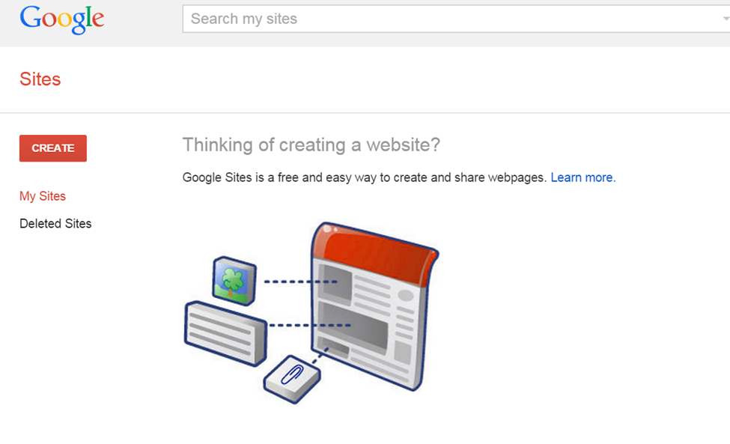
3. Select the background template for your site
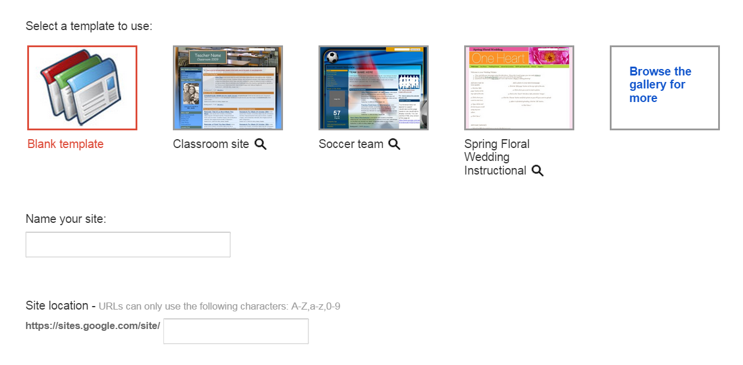
4. Name your site. This will become your URL. This URL must be unique.
5. Select a theme for your background font and color
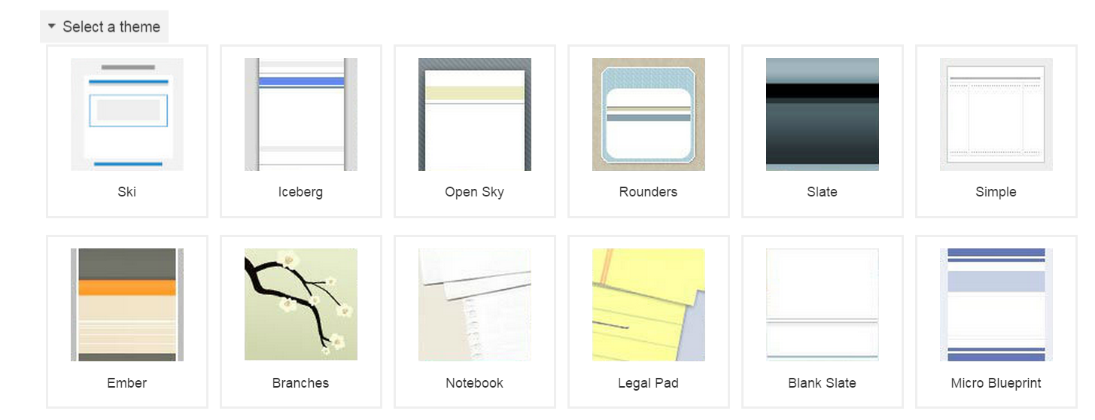
6. Type the code to verify you’re not a robot
7. Select Create at the top
You now have your website!

Editing your webpages
- Select the Edit pencil to type and make changes to your webpage

- Use the edit bar to change font size, style, color and formatting.

- Select Insert to add non-text elements such as images or links to internal and external webpages.
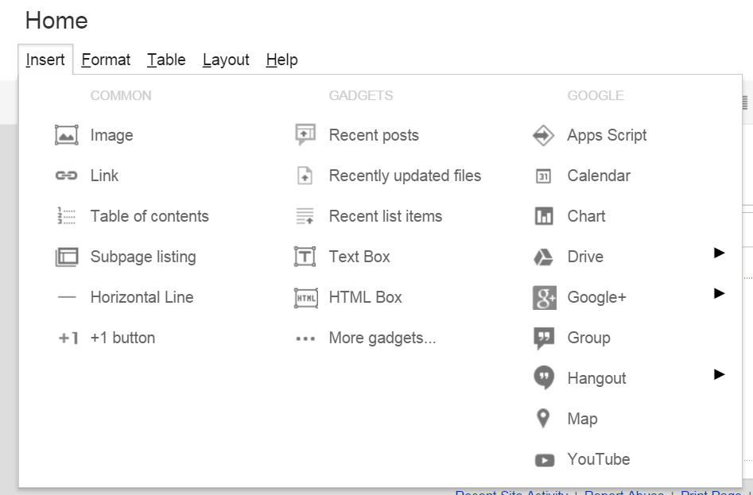
3a. To create an internal link that links to another page within your website, select Insert => Link=> Sites page and choose the page from your Site map
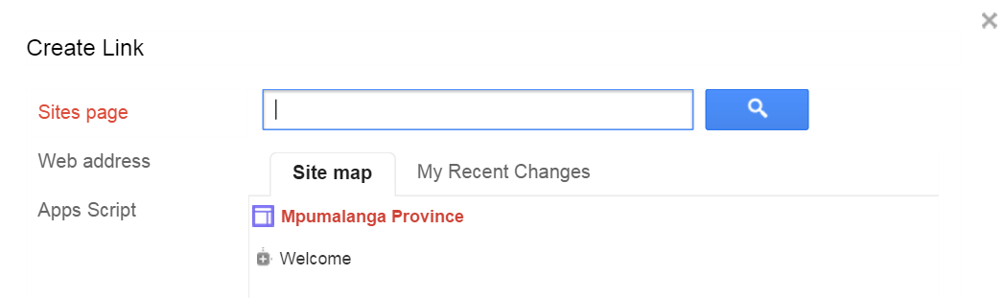
3b. To create an external link that links to a website somewhere else on the internet, select Insert => Link=> Web address, type the text to be highlighted (or linked) and paste the URL.
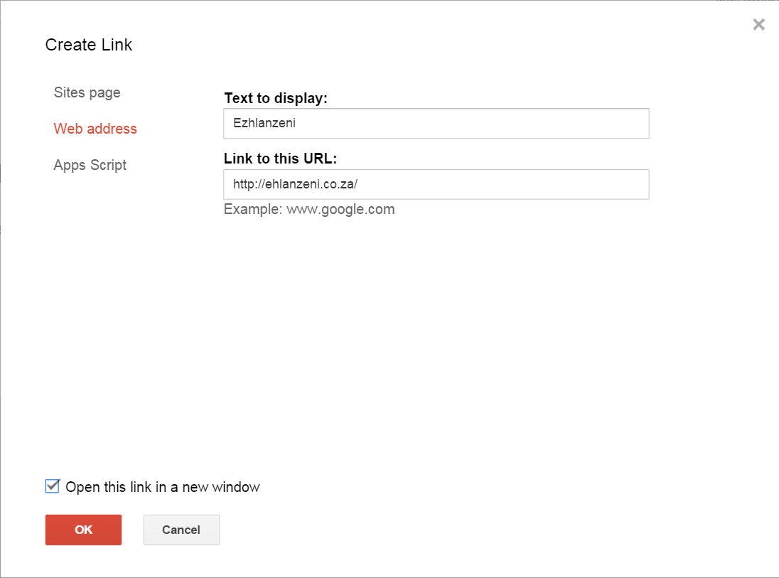
3c. To insert an image, select Insert => Image and either upload an image or paste an image URL
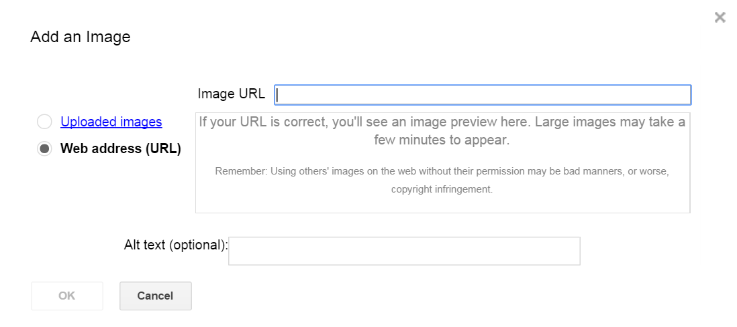

Adding internal webpages
- Select the new page icon to add another webpage to your website

- Type the name of this new page, select the template you wish to use, and whether this page will be a main page or a subpage under a different main page.
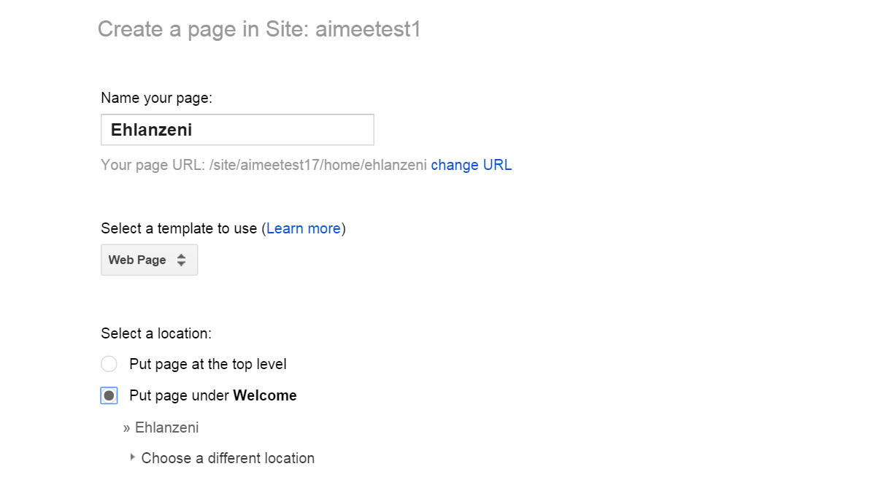

Adding content from Google FusionTables
- In Google FusionTables, select the inverted triangle next to the element (i.e. map or graph) you wish to add to your website
- Select Publish
- Copy the entire content under ‘Paste HTML to embed in a website’ (*Note: your FusionTable privacy must be set to allow those with the link to view)
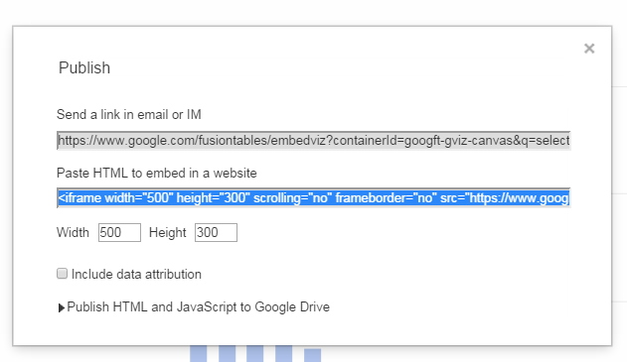
- Return to your website
- Select the Edit pencil to insert the content onto the present page

- On the edit bar, select <HTML>.
- Paste the copied HTML code
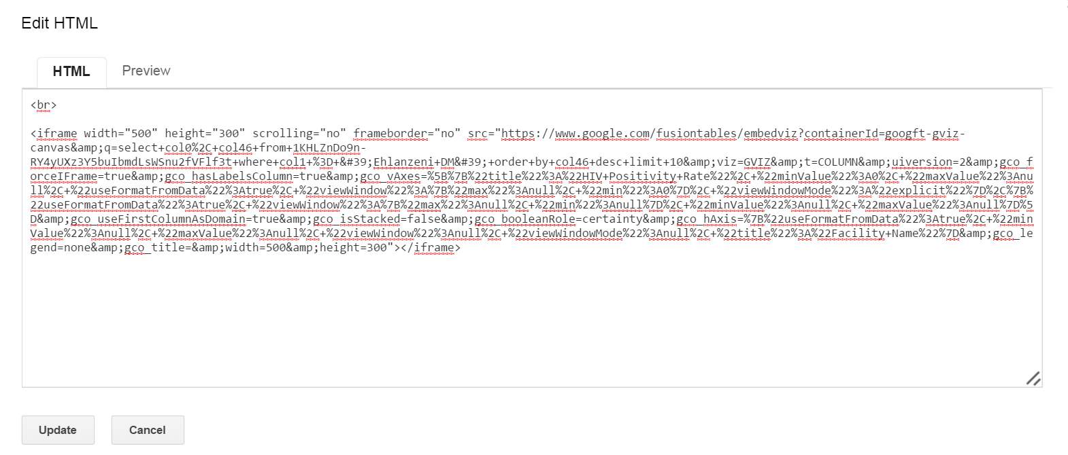
- Select Update

Website privacy
- To edit who has access to your website, select Share

- Change Who has access to ‘Anyone who has the link can view’
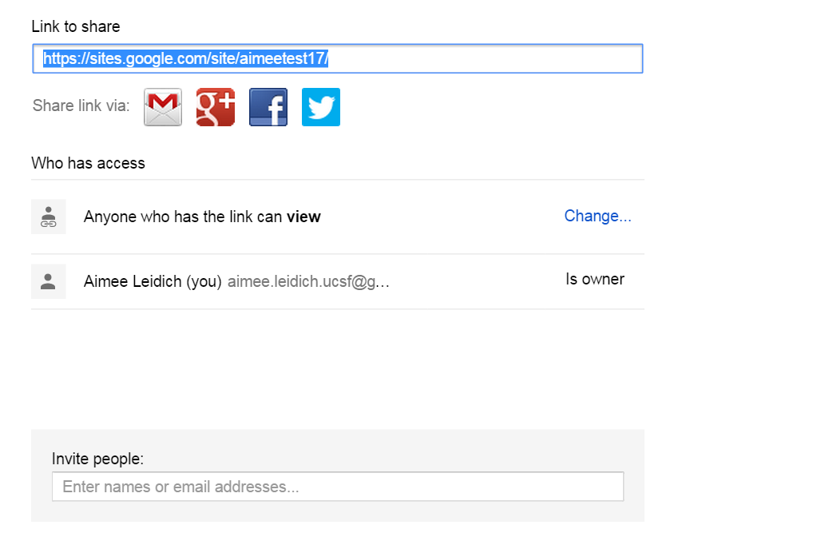

Saving content as a PDF
- Select settings
- Select print page to make a PDF of the contents
